Performed all Constraints with examples

Create two tables(employee and Department)Not Null,  
Primary Key  
Foreign Key  
Unique Key  
Default  
Check

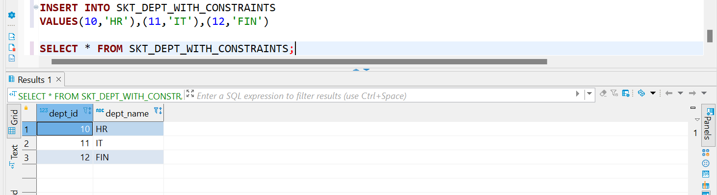

We cannot leave the primary key null

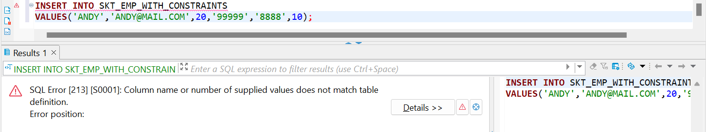

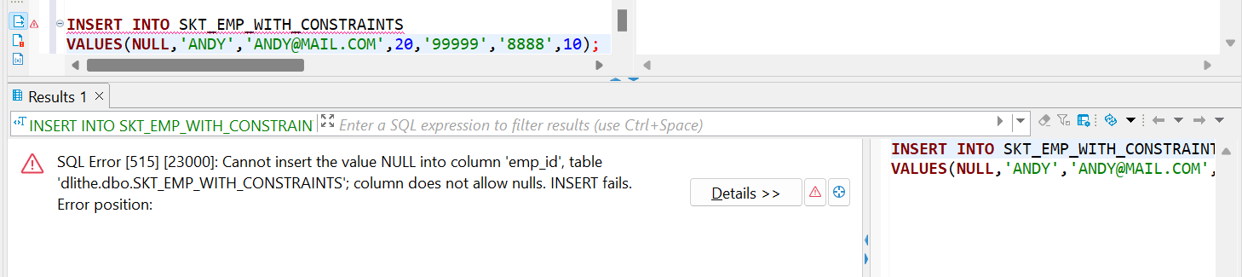

We cannot insert duplicate values in the primary key column

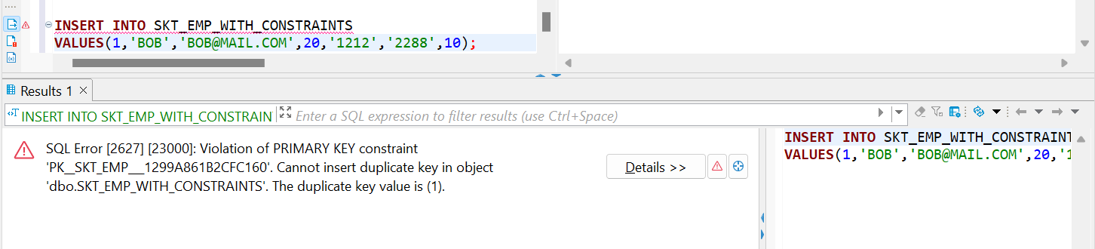

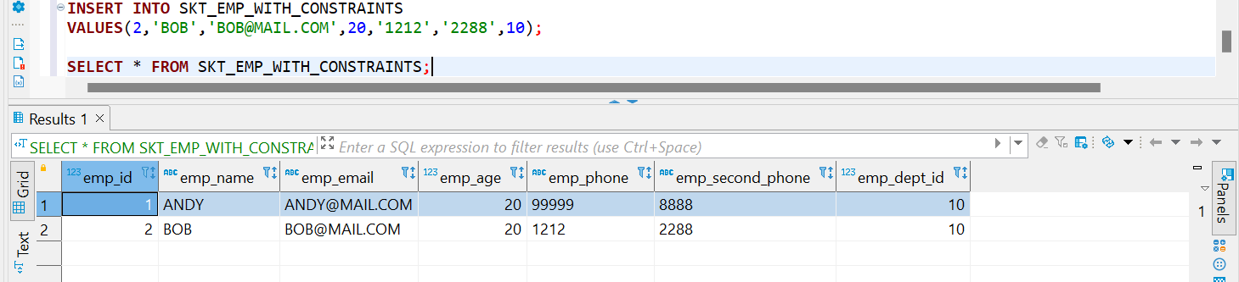

WE CANNOT INSERT NULL VALUES INTO emp_name BECAUSE WE HAVE ASSIGNED IT A NOT NULL CONSTRAINT

WE CANNOT INSERT A VALUE INTO THE MAIL COLUMN BECAUSE IT HAS A UNIQUE KEY CONSTRAINT

WE CANNOT INSERT A PERSON WHO’S AGE IS LESS THAN 18 BECAUSE OF THE CHECK CONSTRAINT

WE CANNOT A PERSON WHO’S DEPT_ID IS NOT IN THE REFERENCED TABLE FOR THE DEPT_ID

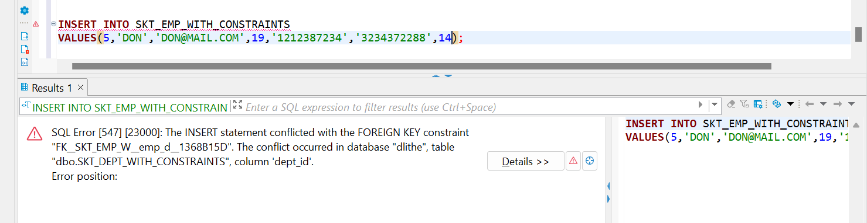

THIS IS THE DEFAULT CONSTRAINT

